Presenting new Presentation card of
Contempo & Contempo Satin – a Design Tuft Collection
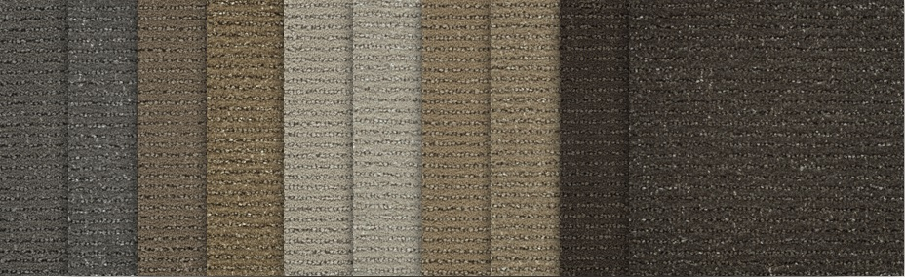

This Presentation Card shows Contempo & Contempo Satin in 5 beautiful colors.
They are available on widths from 3’ to 15’ per your specification and color.

Manufactured and Available to Ship within 7-10 business days

Please call us to discuss any questions or details: 770.949.5676
Your RedRock team members are ready to serve you and your customer!

